You are working as a Devops Administrator. You’ve been tasked to deploy a multitier application on Kubernetes Cluster. The application is a NodeJS application

available on Docker Hub with the following name:

devopsedu/employee

This NodeJS application works with a mongo database. MongoDB image is available

on DockerHub with the following name:

mongo

You are required to deploy this application on Kubernetes:

• NodeJS is available on port 8888 in the container and will be reaching out to port

27017 for mongo database connection

• MongoDB will be accepting connections on port 27017

You must deploy this application using the CLI.

Once your application is up and running, ensure you can add an employee from the

NodeJS application and verify by going to Get Employee page and retrieving your input.

Hint: Name the Mongo DB Service and deployment, specifically as “mongo”

### **Commands**

az group create --name rgKubernete --location eastus

az aks create -g rgKubernete -n myAKSCluster --enable-managed-identity --node-count 1 --generate-ssh-keys

az aks install-cli

az aks get-credentials --resource-group rgKubernete --name myAKSCluster

kubectl apply -f deployment-backend.yaml

kubectl expose deployment mongo --type=Clusterip --port=27017

kubectl apply -f deployment-frontend.yaml

kubectl expose deployment front-end --type=NodePort --port=8888

az group delete --name rgKubernete --yes --no-wait

### **Create Resource Group**

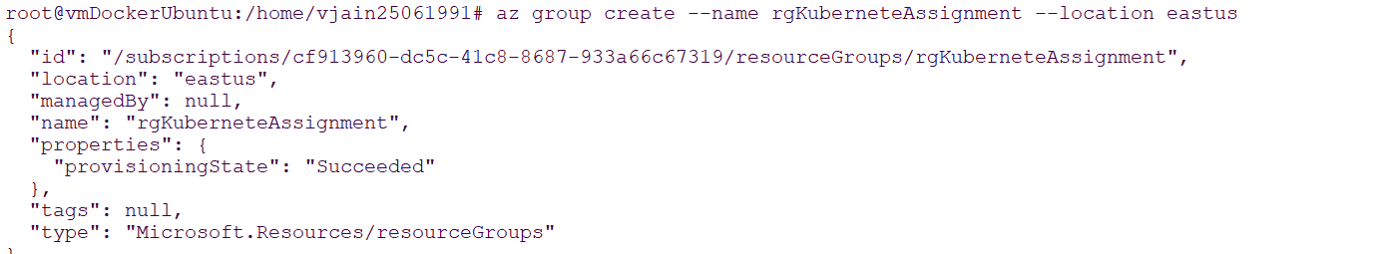

### **Create cluster**

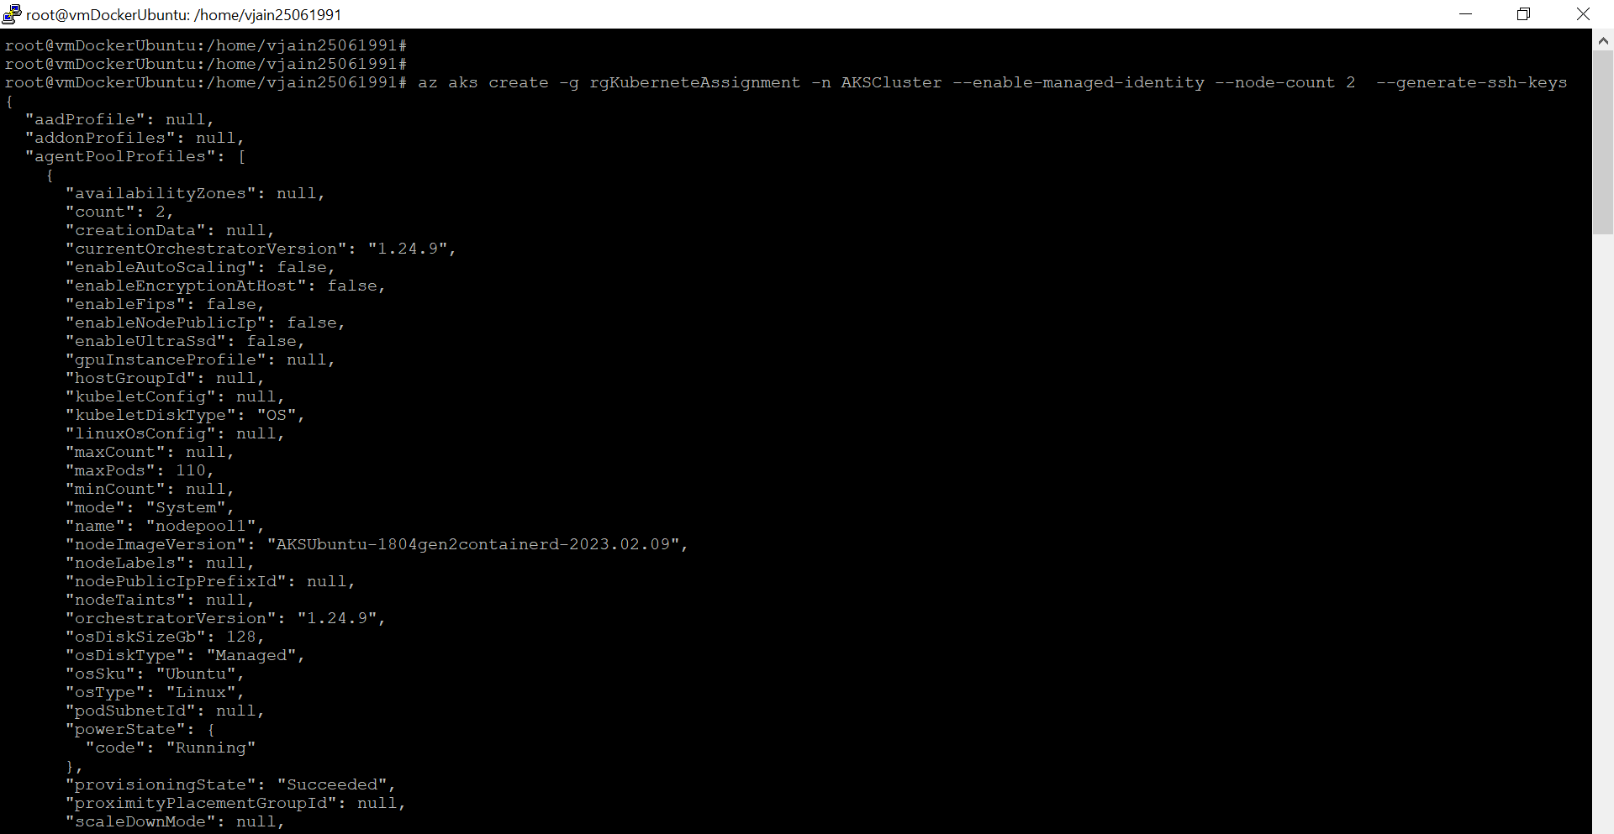

### **Install kubectl**



### **Connect with Cluster**

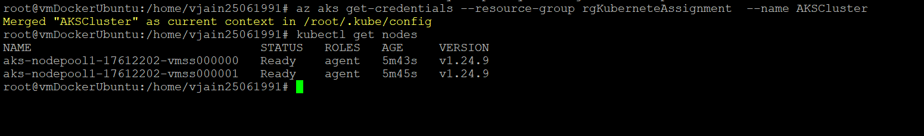

### **Deploying in cluster**

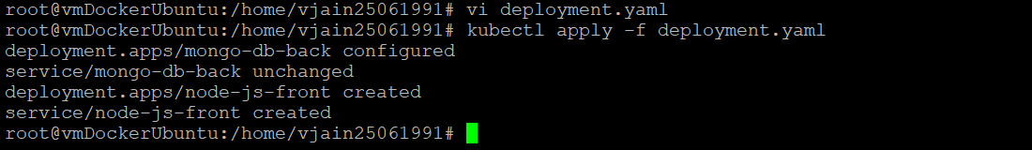

### Yaml file for Deployment



### Testing

